1. 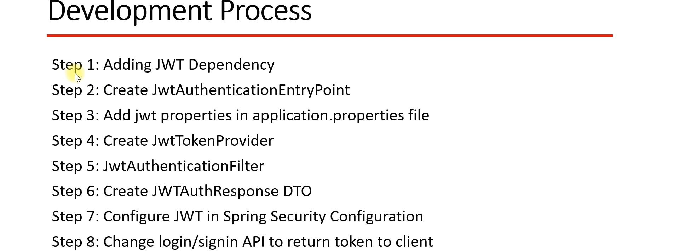
2. **Step 1: Adding JWT Dependency.**  
   
3. **Step 2: Creating JwtAuthenticationEntryPoint.**Used to throw exception due to un-authorized access from the client.  
   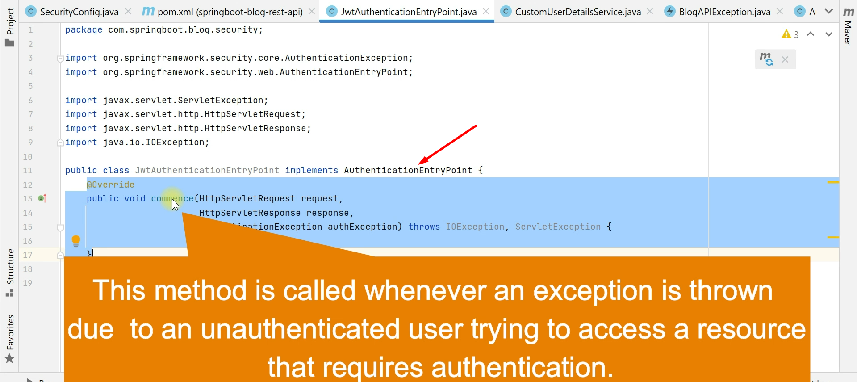  
   

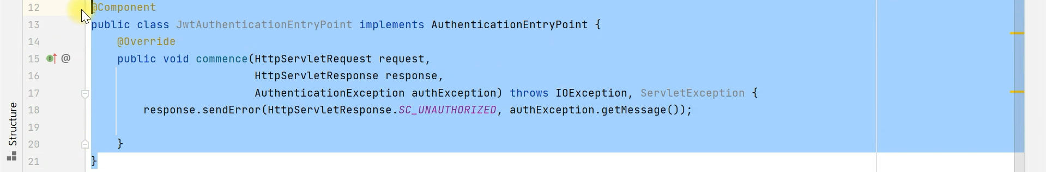

1. **Step 3: Add JWT properties in the application.properties file**.  
   